Linux Firewall Exploration Lab

Name: JASHWANTH REDDY GANGULA

SUID: 646254141

**2.1 Task 1: Using Firewall**  
In this task, we need to setup two VM say VMA and VMB. We need to prevent Virtual Machine A from telneting to Virtual Machine B. First I will demo that we are able to login without any firewall and then we will apply the rule to drop the telnet packets.

VMA has IP address 10.0.2.6

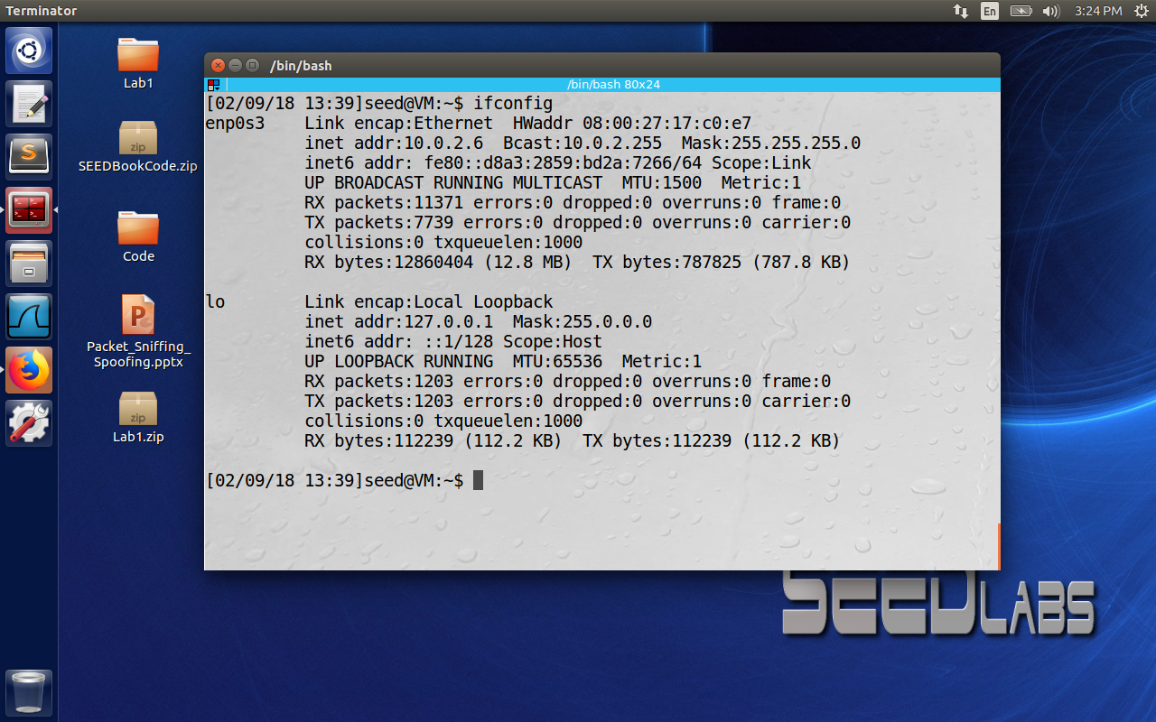

VM B has IP address 10.0.2.8

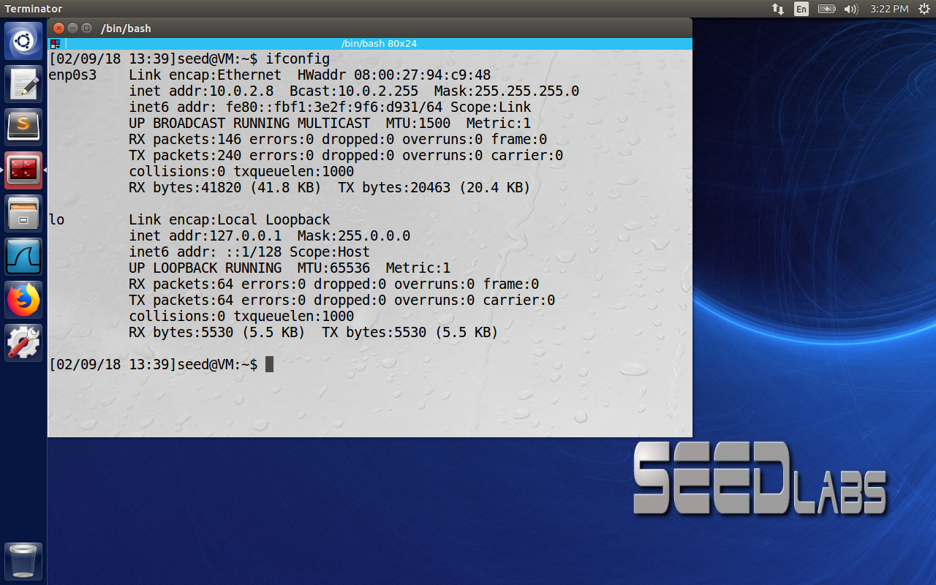

Here I have telneted from Virtual Machine B to A and was successful.

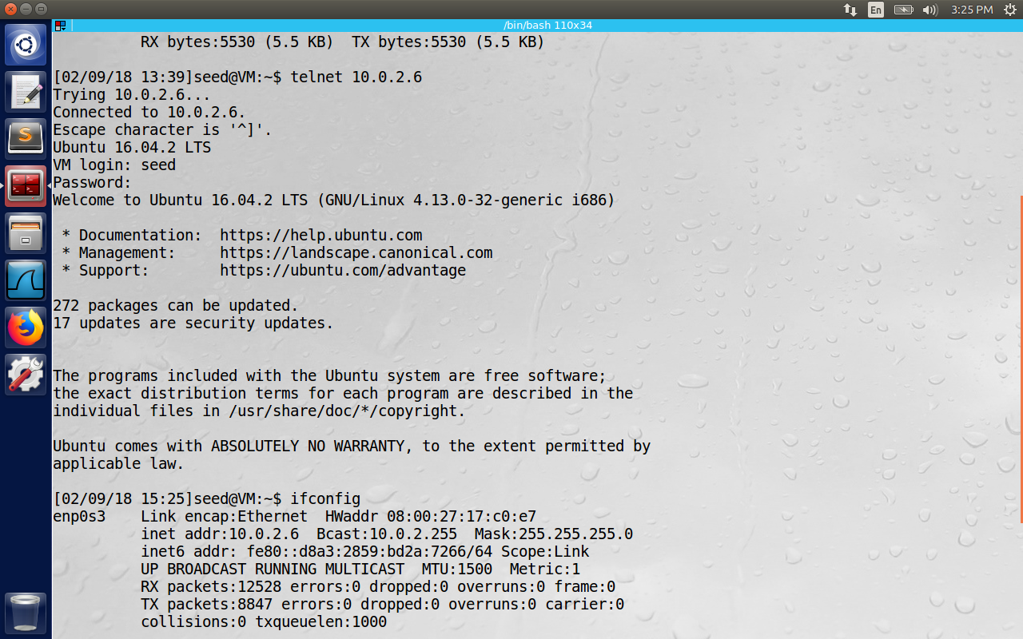

ufw is a program that provides interface to manage the netfilter firewall. Ufw enable reloads

the firewall and enables firewall on boot. Since the telnet daemon listens on port 23, we disable the incoming packets on port 23 using the command ‘ufw deny 23/tcp’

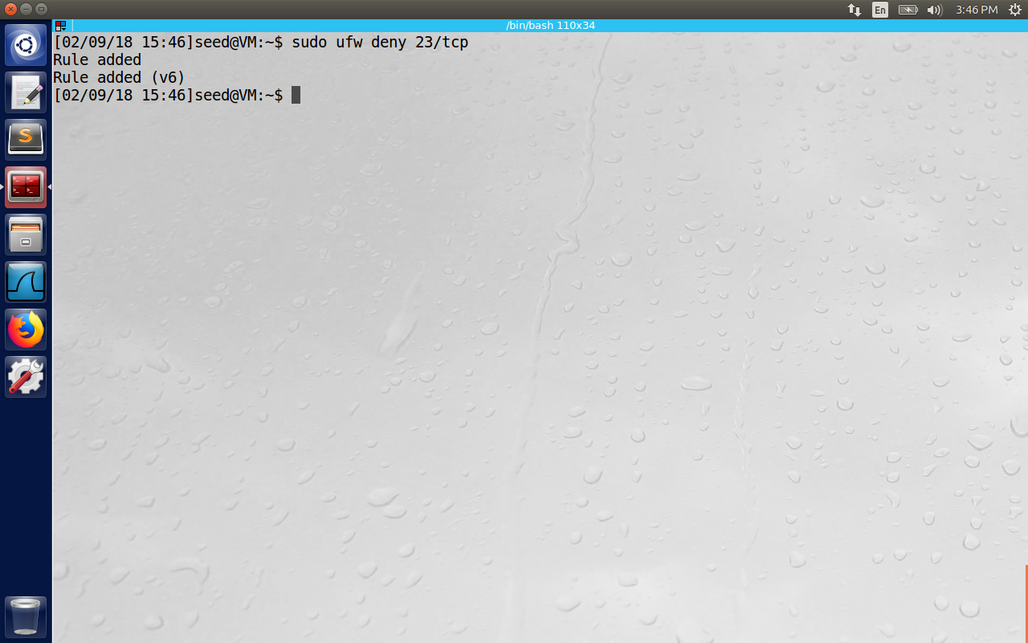

Now We try to telnet to VM A from B, and the login is not successful since the incoming packets to port 23 on VM A are dropped.

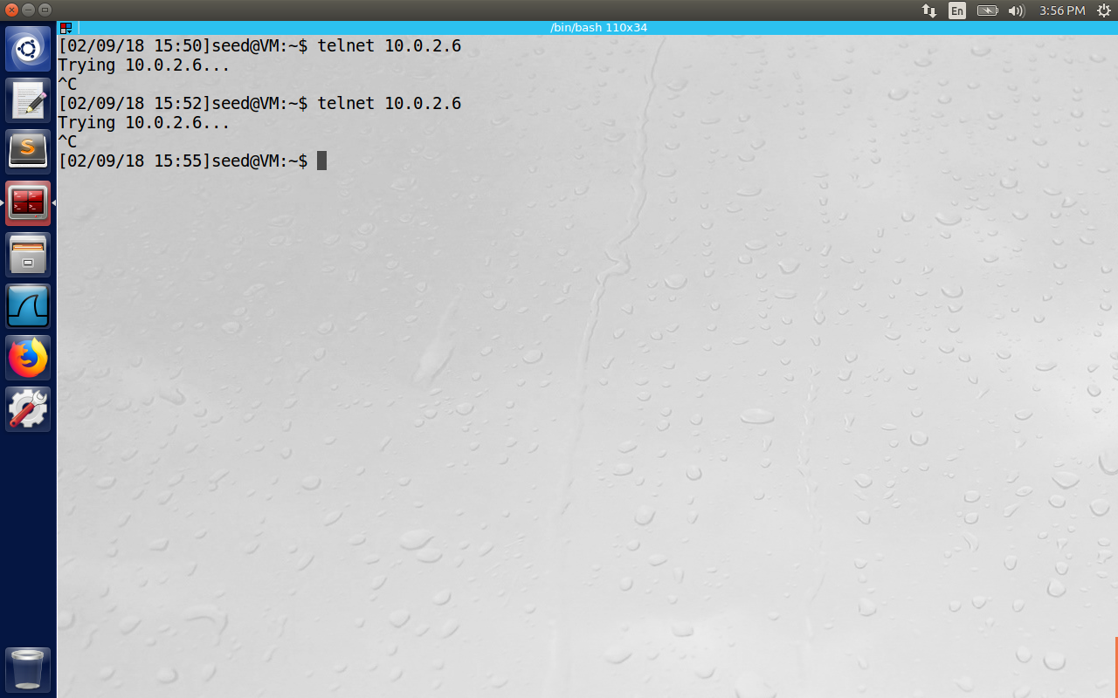

Now to prevent A to telnet to B, we can similarly deny all the incoming traffic on B, or the outbound traffic on A. I have used the second idea so that A has all the rules together.   
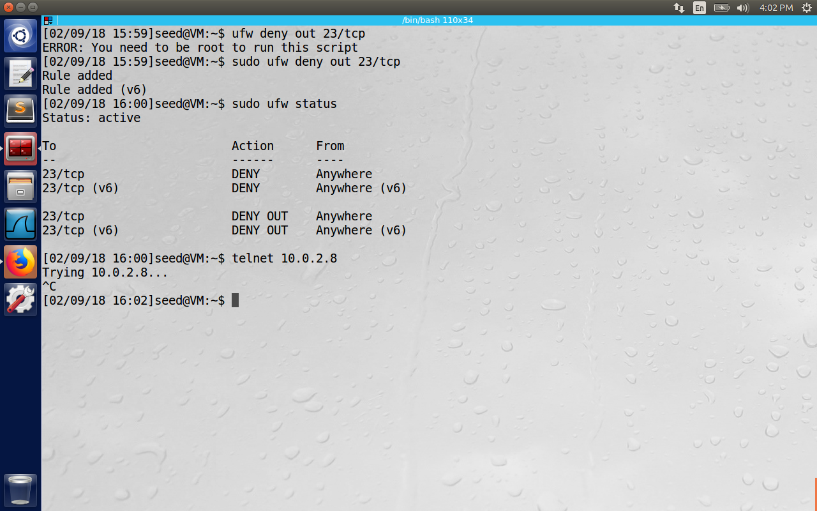

**Prevent A from visiting an external web site. You can choose any web site that you like to block, but keep in mind, some web servers have multiple IP addresses.**

Here I tried to ping facebook and observed a couple of IP address 157.240.2.35 and 157.240.18.35 and hence added the rule to block both the IP using “sudo ufw deny out to 157.240.18.35.”

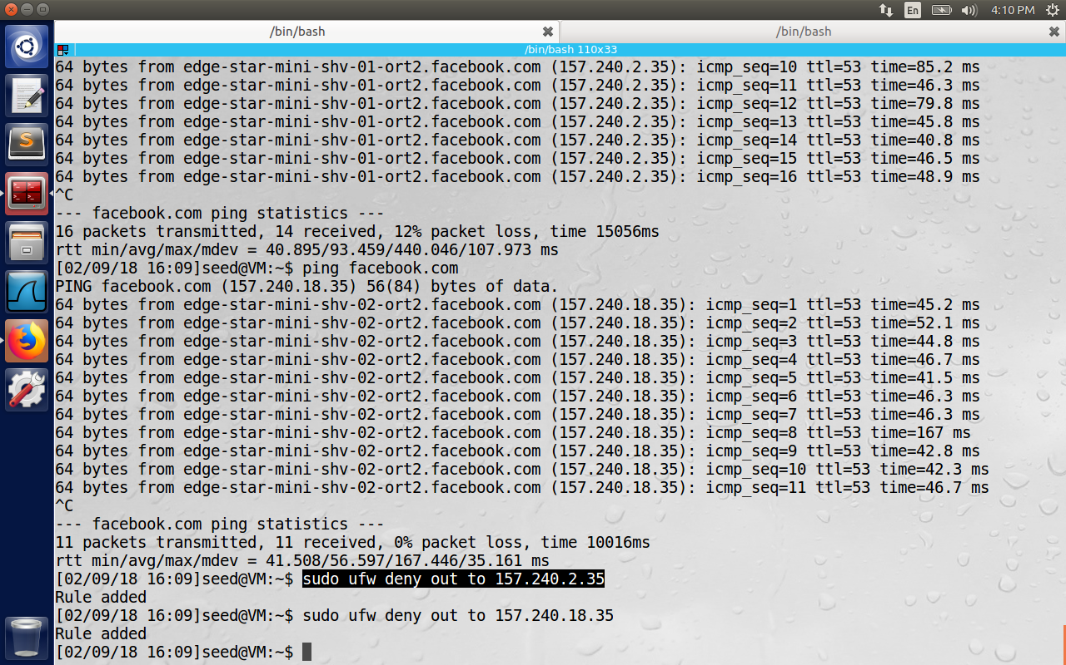

Observed that ping was not successful after the rules were installed.   
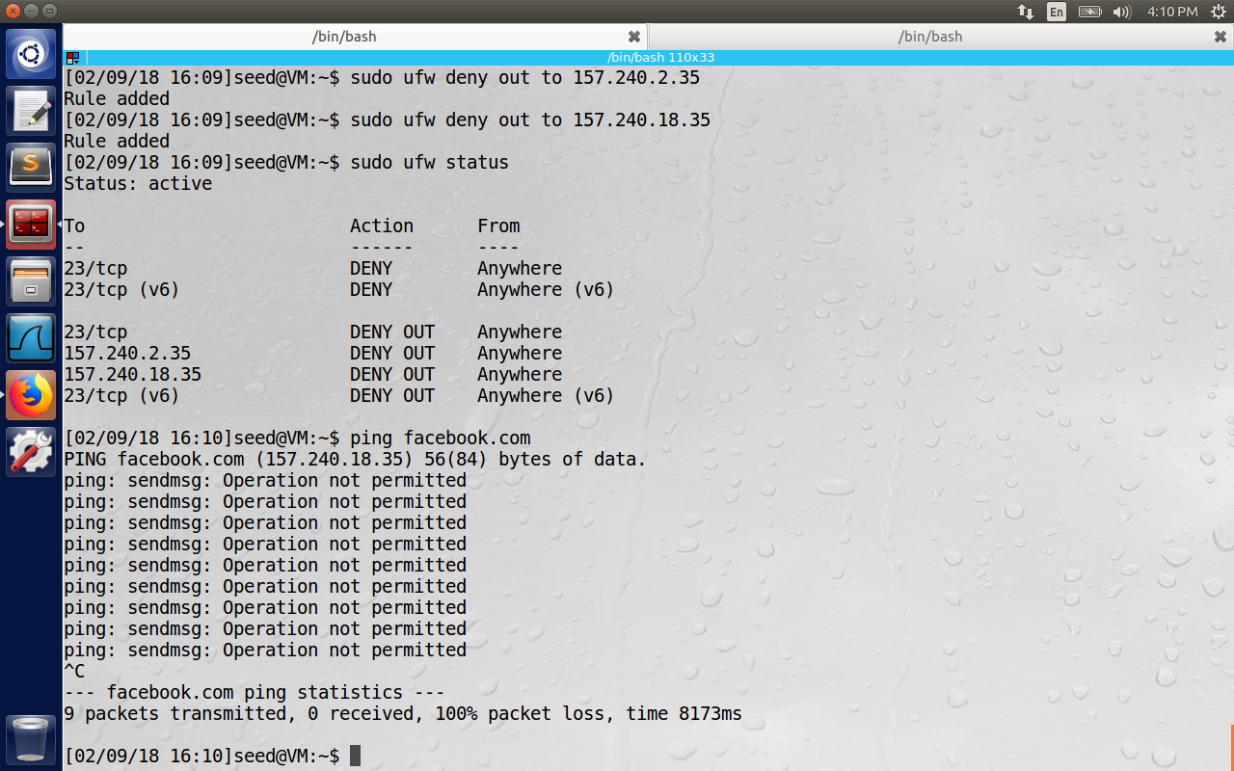

**2.2 Task 2: How Firewall Works**

The modern Linux OS enables us to create firewall using either LKM (loadable kernel module) and Netfilter. Even though LKM extends kernel functionalities, we need to insert code in the packet ingress/egress path and make decisions for firewalls to work. Linux came up with netfilter for the same purpose. We need to connect our programs at particular hooks provide by the netfilter based on our requirements.

Question 1: What types of hooks does Netfilter support, and what can you do with these hooks? Please draw a diagram to show how packets flow through these hooks

Reference: <http://www.netfilter.org/documentation/HOWTO//netfilter-hacking-HOWTO-3.html>

Found the hooks at the location: /usr/src/linux-headers-4.13.0-31/include/uapi/linux/netfilter.h

enum nf_inet_hooks {

NF_INET_PRE_ROUTING,

NF_INET_LOCAL_IN,

NF_INET_FORWARD,

NF_INET_LOCAL_OUT,

NF_INET_POST_ROUTING,

NF_INET_NUMHOOKS

};

-->[1]--->[ROUTE]--->[3]--->[4]--->

| ^

| |

| [ROUTE]

v |

[2] [5]

| ^

| |

v |

On the left is where the packet comes in after basic checks like checksum, truncation, not promiscuous receive packet etc. then they are passed to NF_INET_PRE_ROUTING (1) hook.

Next they enter the routing mode, where they check where is destined for, i.e., whether it is a packet to local process or other interfaces. The route may drop packets that are unreachable.

If it is destined for the box itself, the netfilter framework is called for NF_INET_LOCAL_IN[2] hook, before being passed to the process if any.

If it’s destined to pass to another interface instead, the netfilter framework is called for NF_IP_FORWARD[3] hook.

The packet then passes through a final filter hook, NF_IP_POST_ROUTING[4] hook, before being put on the wire again.

The NF_IP_LOCAL_OUT [5] hook is created for packets that are created locally. Here the routing occurs after this hook is called: in fact, routing code is called first (to figure out source IP and some IP options)

Question 2: Where should you place a hook for ingress filtering, and where should you place a hook for egress filtering?

Ingress filtering is applied for incoming packets. The hook should be placed at NF_INET_PRE_ROUTING so that hook gets called even before the routing code so that incoming packets coming from NIC may be directly processed before they are modified.  
Egress filtering is applied for outgoing packets. The hook should be placed last before they reach the NIC card on the device. Here the hook should be placed at NF_INET_POST_ROUTING.

Question 3: Can you modify packets using Netfilter?

Even though the purpose of Netfilter is to filter the packets based on Firewall rules on the packet processing path, manipulation of packets can be done by authorized users. For this we need to connect our programs with Loadable Kernel Module(LKM) to the corresponding hooks.

**Task 2.2 b**

In this task, you need to use LKM and Netfilter to implement the packet filtering module. This module will fetch the firewall policies from a data structure, and use the policies to decide whether packets should be blocked or not. You should support at least five different rules, including the ones specified in the previous task.

First we will demonstrate how the kernel module should be written, compiled, inserted and removed for a simple hello world program.

The screenshot 1 contains the source code of hello.c contains module initialization and cleanup which are called when the module is loaded and remove from the kernel.

The screenshot 2 shows the make successful, and used sudo insmod hello.ko to insert into the   
kernel and dmesg | tail -10 shows the print output of initializing code.

In the third screenshot, at the end the module is removed using sudo rmmod mymod.ko and the print of the output is observed on the last line of file /var/log/syslog.

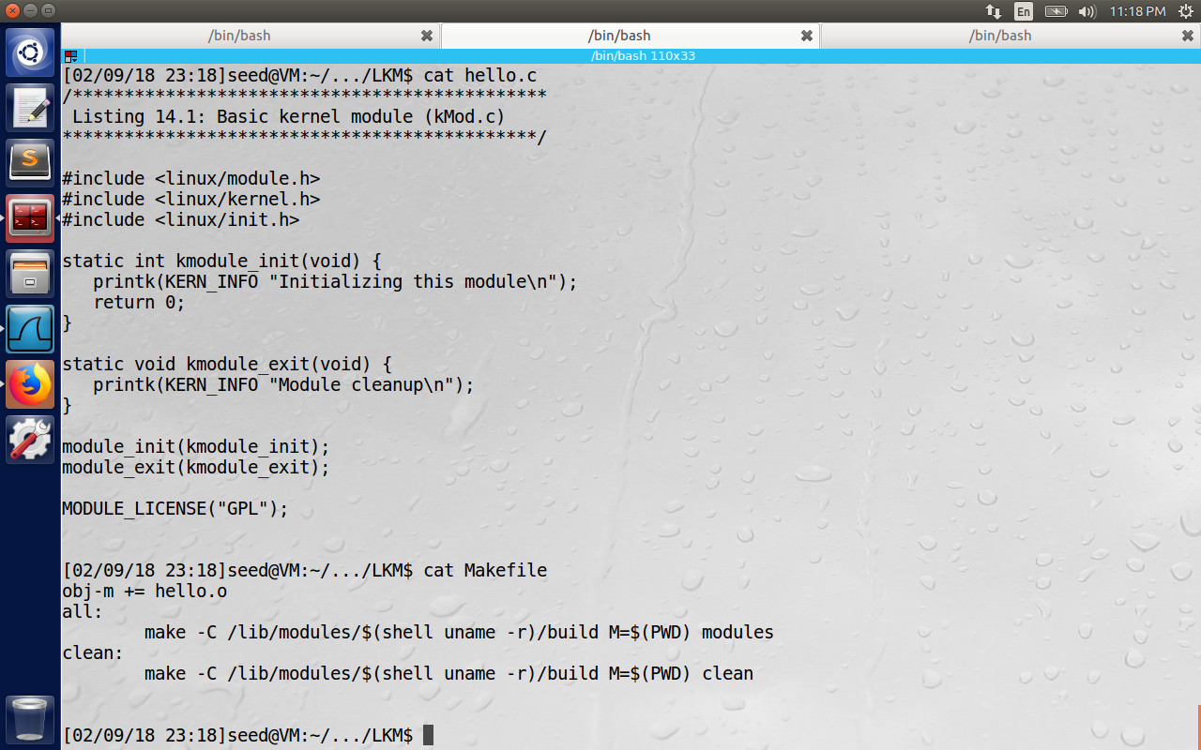

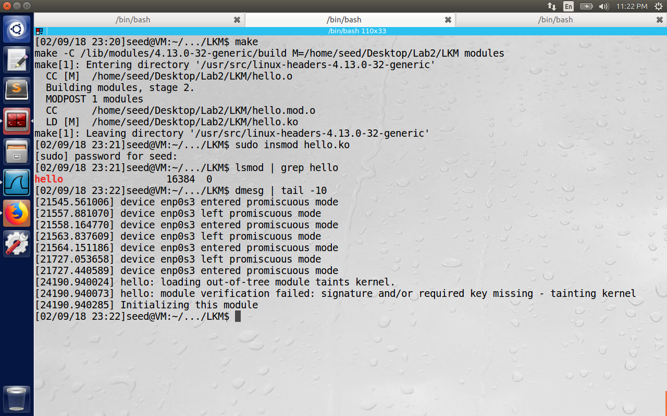

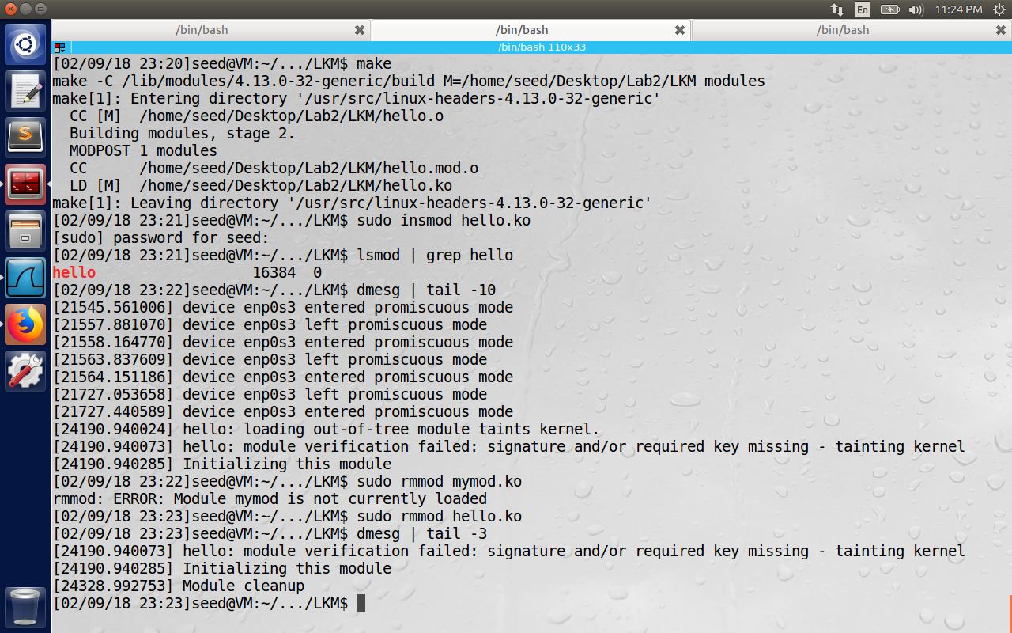

**Netfilter Part:**

The following rules are installed through the netfilter module.

For outgoing packets:

**Rule 1:**

Drop ping packets to Destination ->Prevent A from visiting [www.syracuse.edu](http://www.syracuse.edu) (128.230.18.198)

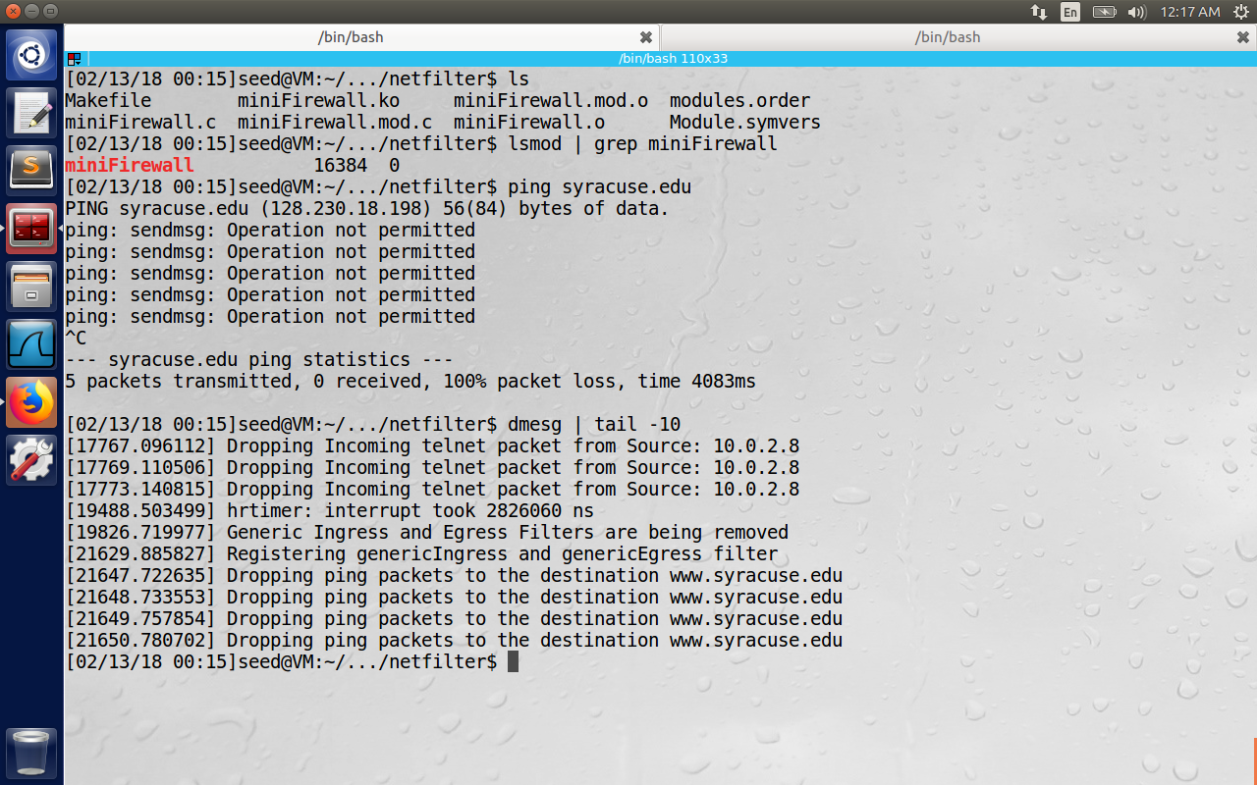

**Rule 2:**

Drop all the outgoing telnet packets -> Prevent VMA from telneting to VM B.

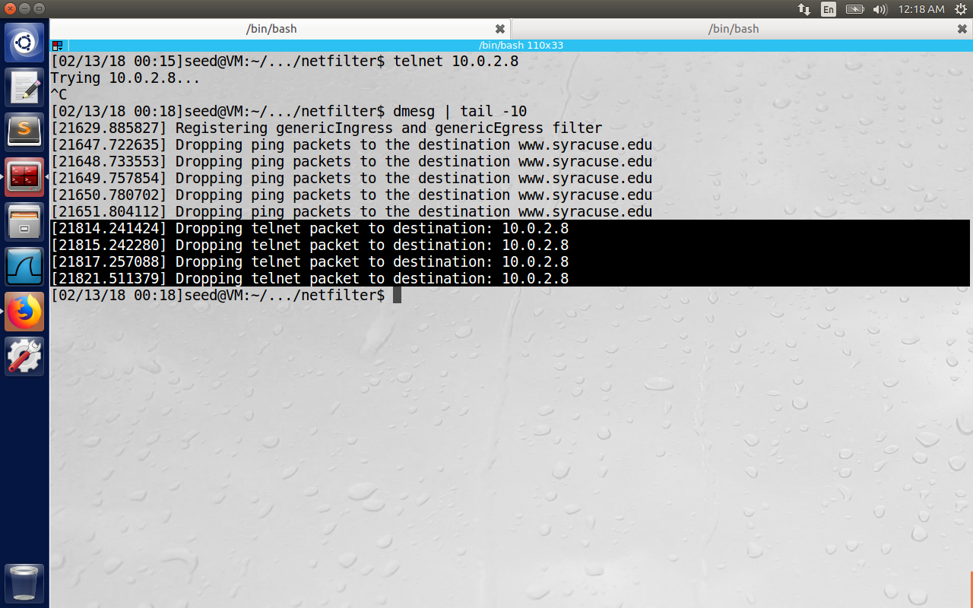

**Rule 3:**

For incoming packets:

Drop all the incoming telnet packets -> Prevent VM B to telnet to VM A.

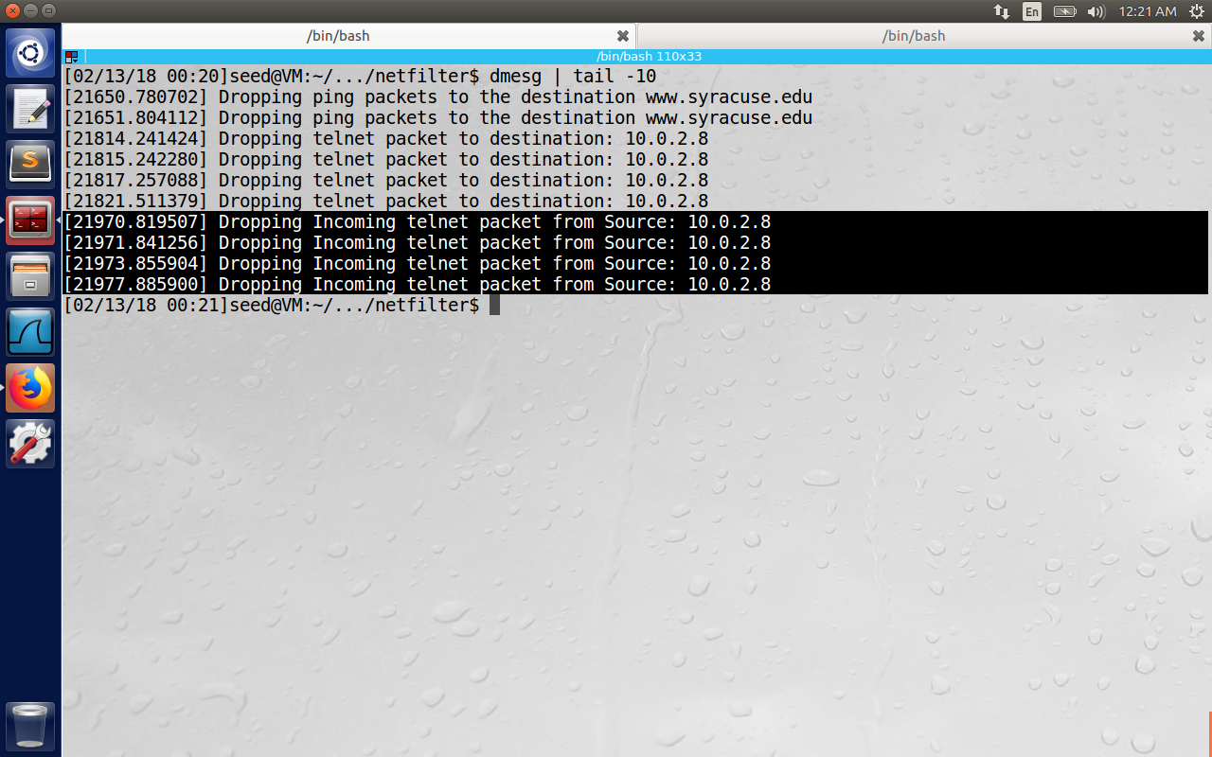

**Rule4:**

For outgoing packets - > Drop Ping request to VM B

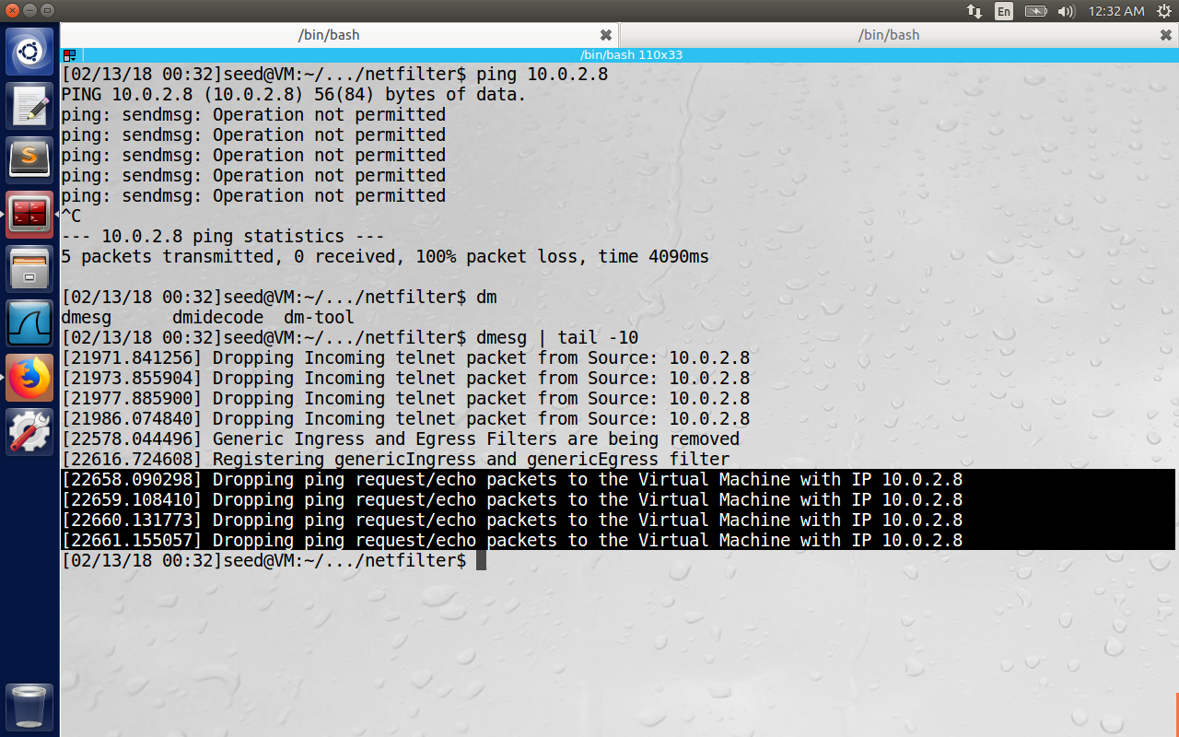

**Rule5:**

For incoming packets-> Drop ping request from VMB with IP 10.0.2.8

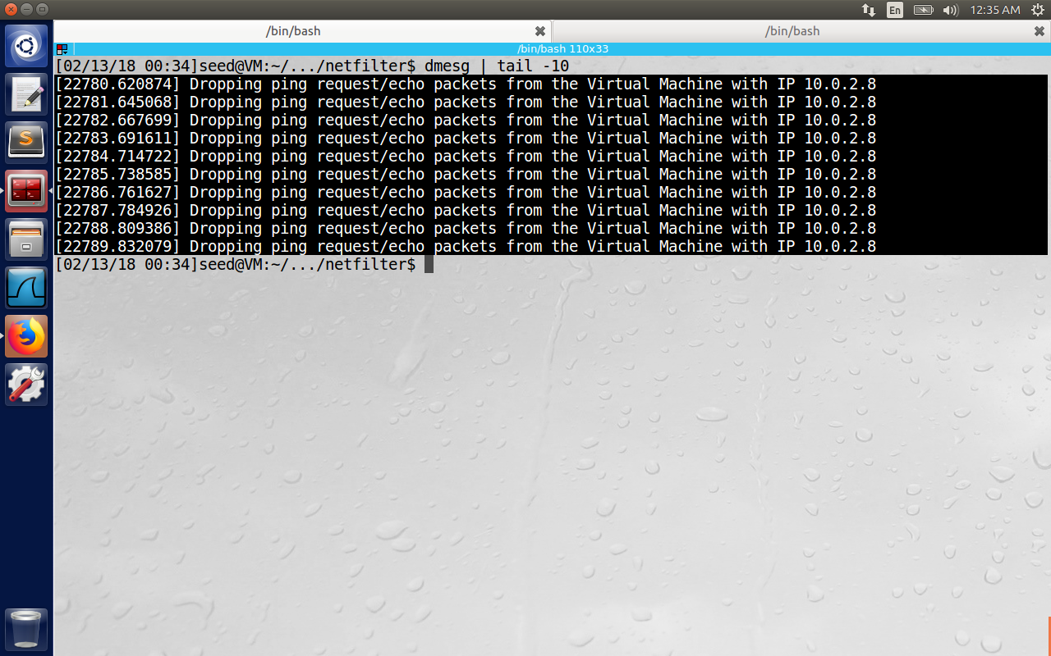

**The Firewall program:**

#include <linux/kernel.h> // We need this for macro expansion for the printk() loglevel

#include <linux/module.h> // Every Kernle module must include this header

#include <linux/netfilter.h> // Contains options to register our function with nf_hook_ops struct

#include <linux/netfilter_ipv4.h> //Contain IPv4 specific definitions for the netfilter

#include <linux/ip.h> // An implementation of TCP/IP protocol suite for LINUX operating system

#include <linux/tcp.h> // TCP headers definitions in the kernel

#include <linux/string.h> // Handlings strings

#include <linux/types.h> // To define kernel level types unsigned int, long int etc.. for kernel level files

// static struct nf_hook_ops telnetFilterHook;

static struct nf_hook_ops netfilter_ops_in; /* NF_IP_PRE_ROUTING */

static struct nf_hook_ops netfilter_ops_out; /* NF_IP_POST_ROUTING */

/**********************************************************************

The below listed signature for hook function in the book example 14.2

by professor Du was for Ubuntu 12.04

Now the signature is changed as in the below method for 16.04 version

unsigned int genericOutFilter(unsigned int hooknum, struct sk_buff *skb,

const struct net_device *in, const struct net_device *out,

int (*okfn)(struct sk_buff *))

**********************************************************************/

unsigned int genericOutFilter(void *priv, struct sk_buff *skb,

const struct nf_hook_state *state)

{

/* Return if the packet is empty */

if (!skb) {

return NF_ACCEPT;

}

struct iphdr *iph;

iph = ip_hdr(skb);

//unsigned int src_ip = (unsigned int)iph->saddr;

//unsigned int dst_ip = (unsigned int)iph->daddr;

char source_ip[16], destination_ip[16];

snprintf(source_ip, 16, "%pI4", &iph->saddr);

snprintf(destination_ip, 16, "%pI4", &iph->daddr);

/* Drop the ping packets to the destination of www.syracuse.edu */

if (strcmp(destination_ip, "128.230.18.198") == 0) {

if (iph->protocol == IPPROTO_ICMP) {

printk(KERN_INFO "Dropping ping packets to the destination www.syracuse.edu");

return NF_DROP;

} else {

return NF_ACCEPT;

}

}

if (strcmp(destination_ip, "10.0.2.8") == 0) {

if (iph->protocol == IPPROTO_ICMP) {

printk(KERN_INFO "Dropping ping request/echo packets to the Virtual Machine with IP 10.0.2.8");

return NF_DROP;

} else {

return NF_ACCEPT;

}

}

if (iph->protocol == IPPROTO_TCP) {

struct tcphdr *tcph;

tcph = (void *)iph+iph->ihl*4;

if (tcph->dest == htons(23)) {

printk(KERN_INFO "Dropping telnet packet to destination: %d.%d.%d.%d\n",

((unsigned char *)&iph->daddr)[0], ((unsigned char *)&iph->daddr)[1],

((unsigned char *)&iph->daddr)[2], ((unsigned char *)&iph->daddr)[3]);

return NF_DROP;

} else {

return NF_ACCEPT;

}

}

else {

return NF_ACCEPT;

}

}

unsigned int genericInFilter(void *priv, struct sk_buff *skb,

const struct nf_hook_state *state) {

/* Return if the packet is empty */

if (!skb) {

return NF_ACCEPT;

}

struct iphdr *iph;

struct tcphdr *tcph;

iph = ip_hdr(skb);

tcph = (void *)iph+iph->ihl*4;

char source_ip[16], destination_ip[16];

snprintf(source_ip, 16, "%pI4", &iph->saddr);

snprintf(destination_ip, 16, "%pI4", &iph->daddr);

if (strcmp(source_ip, "10.0.2.8") == 0) {

if (iph->protocol == IPPROTO_ICMP) {

printk(KERN_INFO "Dropping ping request/echo packets from the Virtual Machine with IP 10.0.2.8");

return NF_DROP;

} else {

return NF_ACCEPT;

}

}

if (iph->protocol == IPPROTO_TCP && tcph->dest == htons(23)) {

printk(KERN_INFO "Dropping Incoming telnet packet from Source: %d.%d.%d.%d\n",

((unsigned char *)&iph->saddr)[0], ((unsigned char *)&iph->saddr)[1],

((unsigned char *)&iph->saddr)[2], ((unsigned char *)&iph->saddr)[3]);

return NF_DROP;

}

return NF_ACCEPT;

}

int setUpFilter(void) {

printk(KERN_INFO "Registering genericIngress and genericEgress filter");

/* telnetFilterHook.hook = telnetFilter;

telnetFilterHook.hooknum = NF_INET_POST_ROUTING;

telnetFilterHook.pf = PF_INET;

telnetFilterHook.priority = NF_IP_PRI_FIRST;*/

netfilter_ops_out.hook = genericOutFilter;

netfilter_ops_out.hooknum = NF_INET_POST_ROUTING;

netfilter_ops_out.pf = PF_INET;

netfilter_ops_out.priority = NF_IP_PRI_FIRST;

nf_register_net_hook(&init_net, &netfilter_ops_out);

netfilter_ops_in.hook = genericInFilter;

netfilter_ops_in.hooknum = NF_INET_PRE_ROUTING;

netfilter_ops_in.pf = PF_INET;

netfilter_ops_in.priority = NF_IP_PRI_FIRST;

nf_register_net_hook(&init_net, &netfilter_ops_in);

/******************************************

nf_register_hook(&telnetFilterHook);

Need to change this as listed in the book

for 12.04 version. The latest changes in 16.04

are as below.

nf_register_net_hook(&init_net, &telnetFilterHook);

*******************************************/

return 0;

}

void removeFilter(void) {

printk(KERN_INFO "Generic Ingress and Egress Filters are being removed");

/**************************************************

nf_unregister_hook(&telnetFilterHook);

Need to change this signature as listed in the book

for 12.04 version. The latest changes in 16.04

are as below

nf_unregister_net_hook(&init_net, &telnetFilterHook);

***************************************************/

// unregister hook function on Ubuntu 16.04 No need to define init_net

// structure as it is already in the netfilter.h header

nf_unregister_net_hook(&init_net, &netfilter_ops_in);

nf_unregister_net_hook(&init_net, &netfilter_ops_out);

}

module_init(setUpFilter);

module_exit(removeFilter);

MODULE_LICENSE("GPL");

**Compilation and kernel module insertion successful screenshot:**

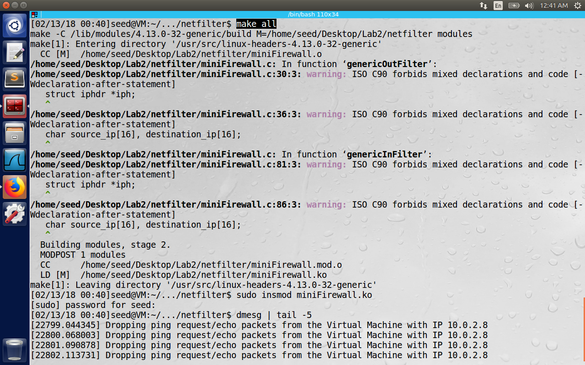

**2.3 Task 3: Evading Egress Filtering**

Sometimes the firewalls need to block some websites with in a corporate network for productivity, or block explicit content to children from watching etc. These kind of filters don’t need deep packet inspection. They check the ip address of the host and block it from reaching within the network using firewalls. In this task, we will bypass this filter using SSH tunneling. In the setup, we use 2 VM’s A and B. For simplicity, we will run the firewall on VM A, though in real world, we can have a dedicated machine running firewall.

Block all the outgoing traffic to external telnet servers.

This is done on VMA using the command ufw deny out 23/tcp.  
Block Facebook, in case the IP address of the server keeps changing we can block university websites where they have constant IP most of the times. (like for example syr.edu)

**Task 3.a:** Telnet to Machine B through the firewall

To bypass the firewall, we establish an SSH tunnel (also called poor man’ VPN, because we do static port forwarding in SSH, where the application needs to telnet to localhost, and we have SSH tunnel listening on that port, which encrypts the IP packets to be sent to end B at the transport layer. At the end B, again the port forwarding is done to the listening application the payload which contains the IP packet.)

The lab asked to establish 3 VM, but in this case we have 2 VM setup and start telnet daemon on VM B itself using the command sudo service openbsd-inetd start.

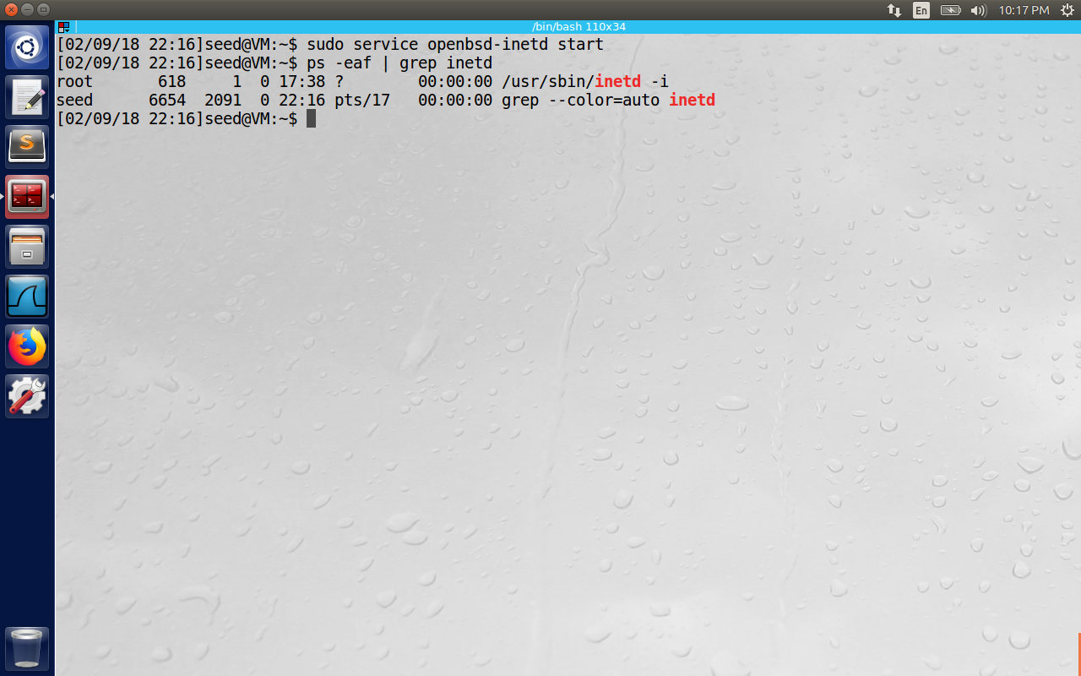

Now create a tunnel on VM A using the command “ssh –L 8000:10.0.2.8:23 seed@10.0.2.8”

-L in the command specifies that connections on the given TCP port (800 here) are to be forwarded to a given host and port. (In case of 3VM’s A, B,C the command should be “ssh –L 8000: Machine_C_IP:23 seed@Machine_B_IP”)

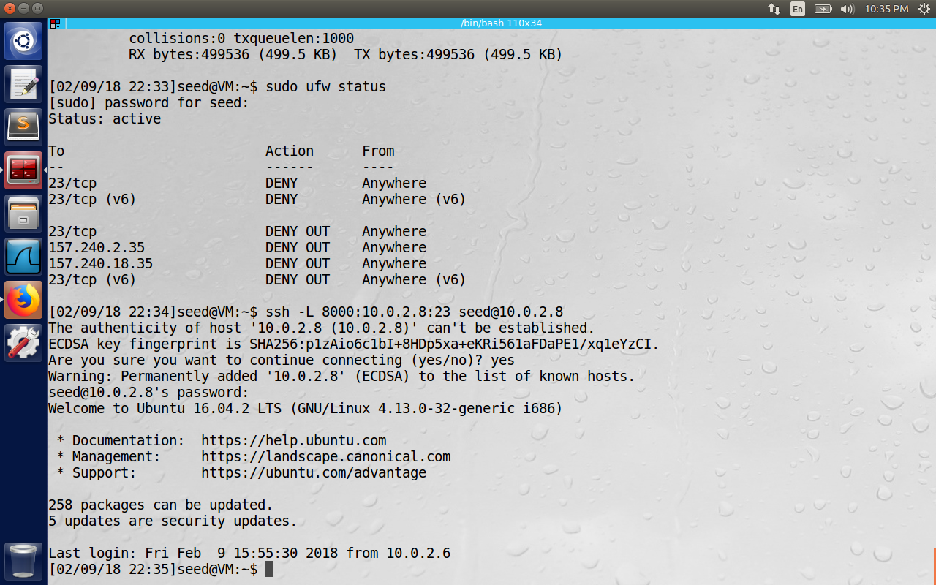

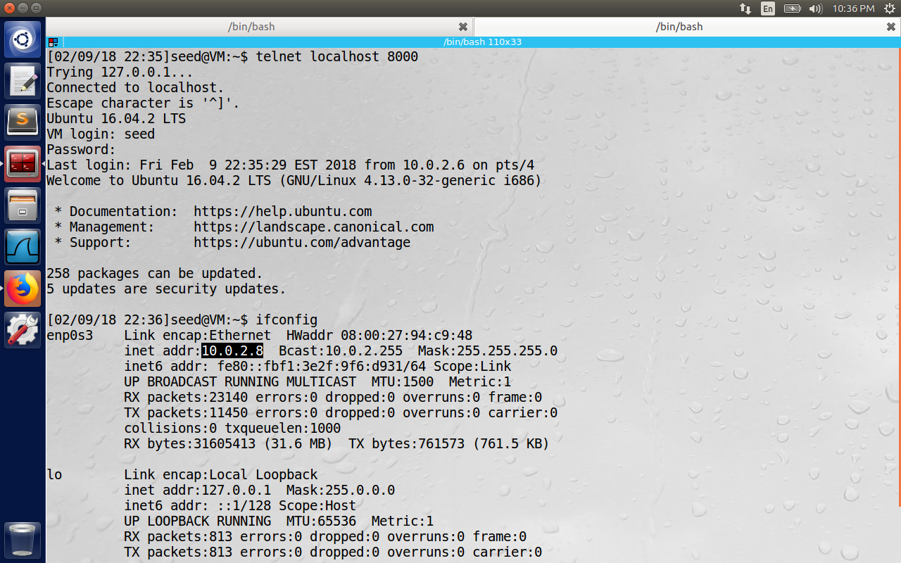

In the first screenshot ssh login was successful and in the second screenshot telnet to localhost resulted in logging in to virtual Machine B (which can be verified using ifconfig command which displays IP of VM B). Here ssh will transfer all the TCP packets from one end of the tunnel (i.e., localhost on VM A to machine B, from there end B will forward packets to port 23, which is the telnet server listening port, hence we have bypassed the firewall.)

**Task 3.b:** Connecting to Facebook using SSH Tunnel  
We can do this similar to as in the task 3.a i.e., we will use [www.syracuse.edu](http://www.syracuse.edu) instead of <http://fb.me> , before of the static IP nature of the previous one. Now we can use the command as “ssh –L 8000:Syracuse_IP:80 seed@Machine_IP”. But we need a more dynamic way of tunneling instead of specifying the destination every time. In dynamic approach, Machine B automatically decides to where the packet destination should be forwarded based on IP information encapsulated in the packet. In task 3.a, we have telneted to localhost and used the ssh tunnel. In this task, we will use Firefox to proxy the requests to localhost:9000.

First an ssh tunnel is established to proxy packets between localhost 9000 to VM B and vice-versa.

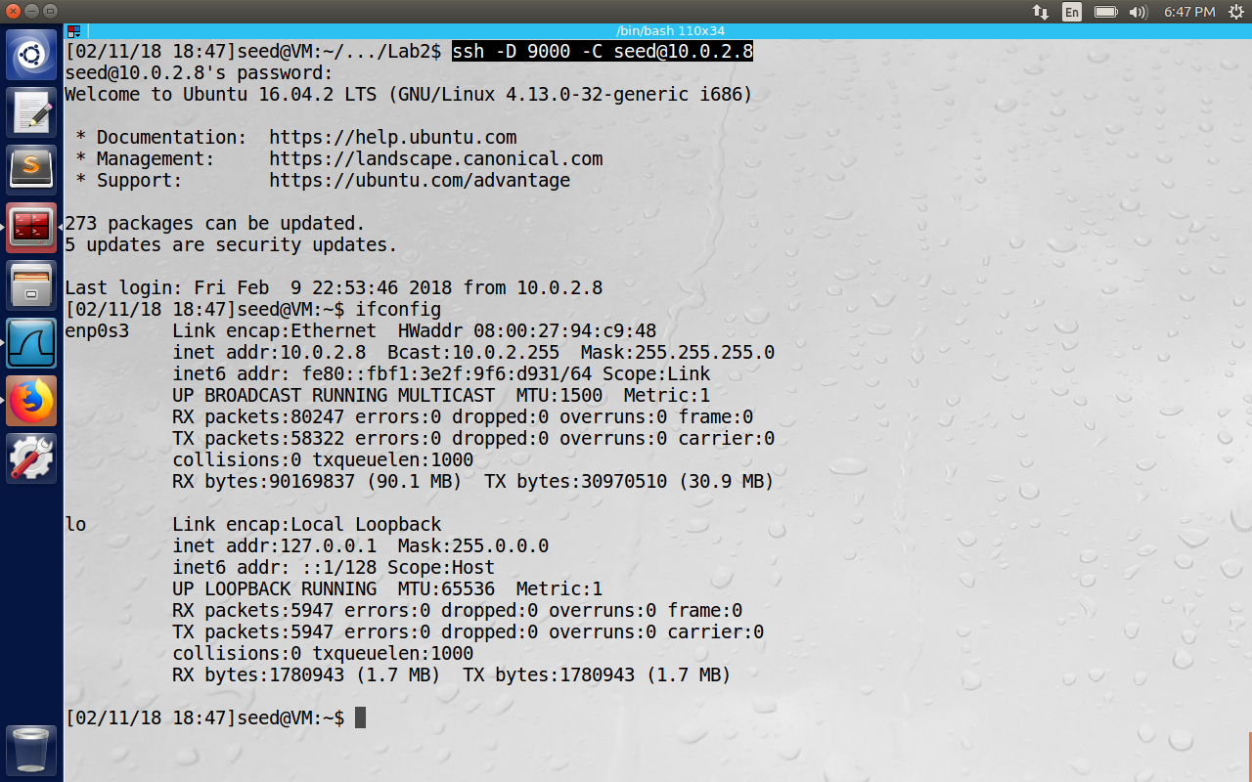

The Firefox is configured with SOCKS Host as shown in the figure.

A SOCKS proxy is basically an SSH tunnel in which specific applications forward their traffic down the tunnel to the server, and then on the server end, the proxy forwards the traffic out to the general Internet. Unlike a VPN, a SOCKS proxy has to be configured on an app by app basis on the client machine, but can be set up without any specialty client agents.

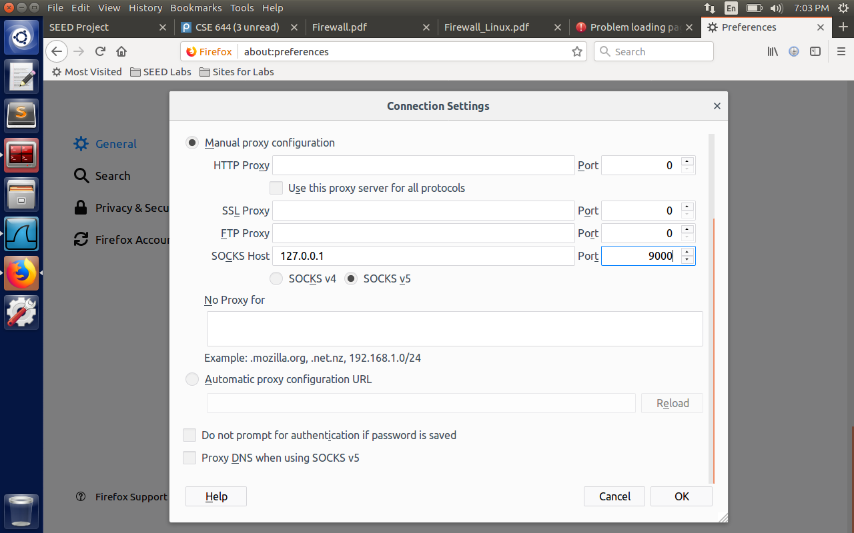

The Wireshark shows the ssh traffic between VM A and B, and the website <http://www.syracuse.edu> was successfully opened on Firefox even after adding the firewall rule to drop the destination packets with IP:128.230.18.198(static IP of Syracuse.edu)

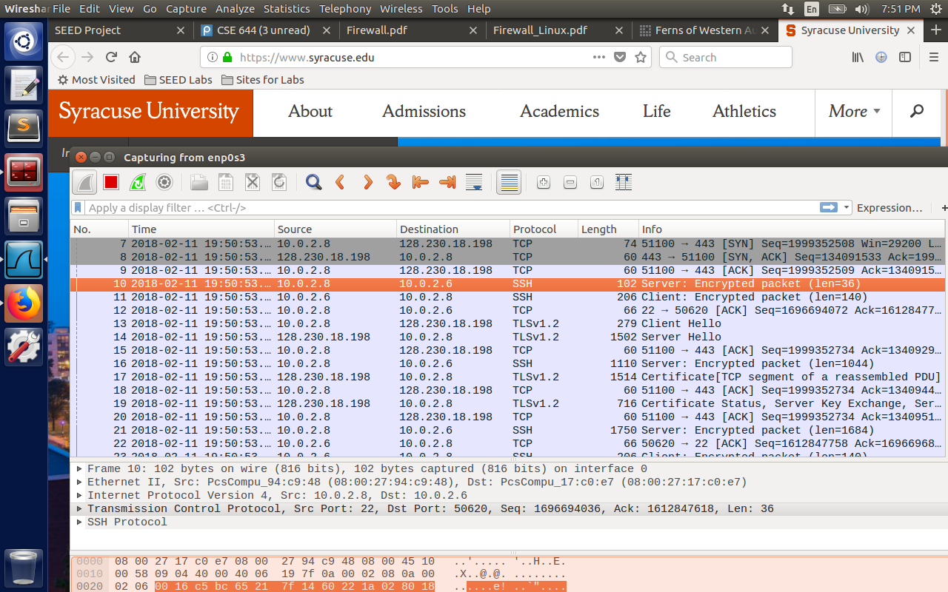

2. After you get the facebook page, break the SSH tunnel, clear the Firefox cache, and try the connection again. Please describe your observation

Now we have broken the connection with SSH tunnel, the page was not loaded with the error proxy refused connections.

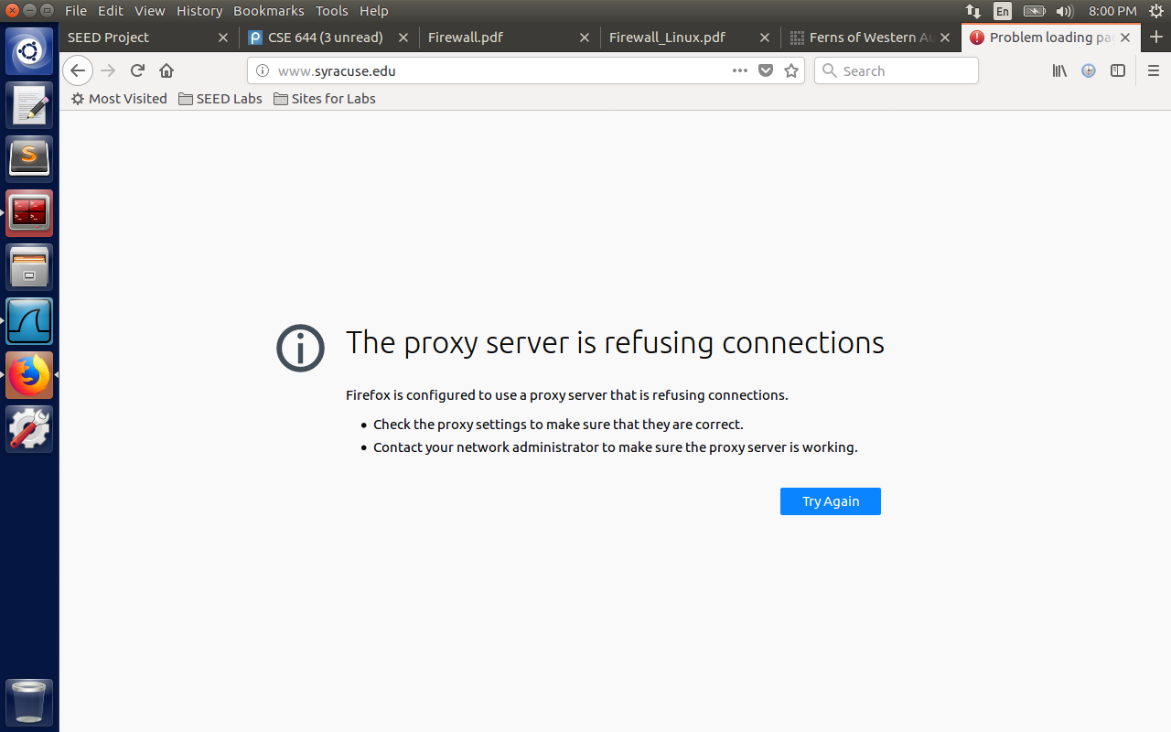

3.Establish the SSH tunnel again and connect to Facebook. Describe your observation.

After we have reestablished the ssh tunnel, the web page was loaded properly.

4. Please explain what you have observed, especially on why the SSH tunnel can help bypass the egress filtering. You should use Wireshark to see what exactly is happening on the wire. Please describe your observations and explain them using the packets that you have captured.

We can observe SSH packets from VMA (10.0.2.6) to VM B(10.0.2.8). We can observer VMB (10.0.2.8) sending requests to Syracuse.edu (120.230.18.198) in the form of TCP handshake (observe SYN, ACK between them). We can see the SSH packets from VMB back to the client as Encrypted packets. Here we observe that we are not giving any destination information on the host(firefox on Machine A, the request reach to port 9000 from where encapsulated IP packets are transported using established tunnel to end B, which forwards the requests to Syracuse.edu based on destination information available in IP packets.) The egress and ingress packets go as if they are destined for Machine B, but the actual destination is encapsulated in this tunnel, by passing the firewall filter.

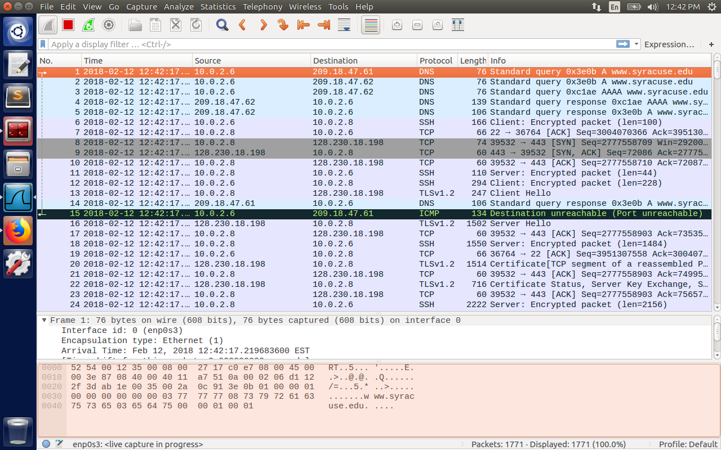

**Question 4:** If ufw blocks the TCP port 22, which is the port used by SSH, can you still set up an SSH tunnel to evade egress filtering?

I have opened /etc/ssh/sshd_config file which has options for which port should the ssh listen to, to which interfaces sshd will bind to etc... If the port 22 is blocked by ufw, we can create another listening port and still evade the egress filtering. But disabling port forwarding configuration will prevent opening backdoors for tunneling through firewalls.

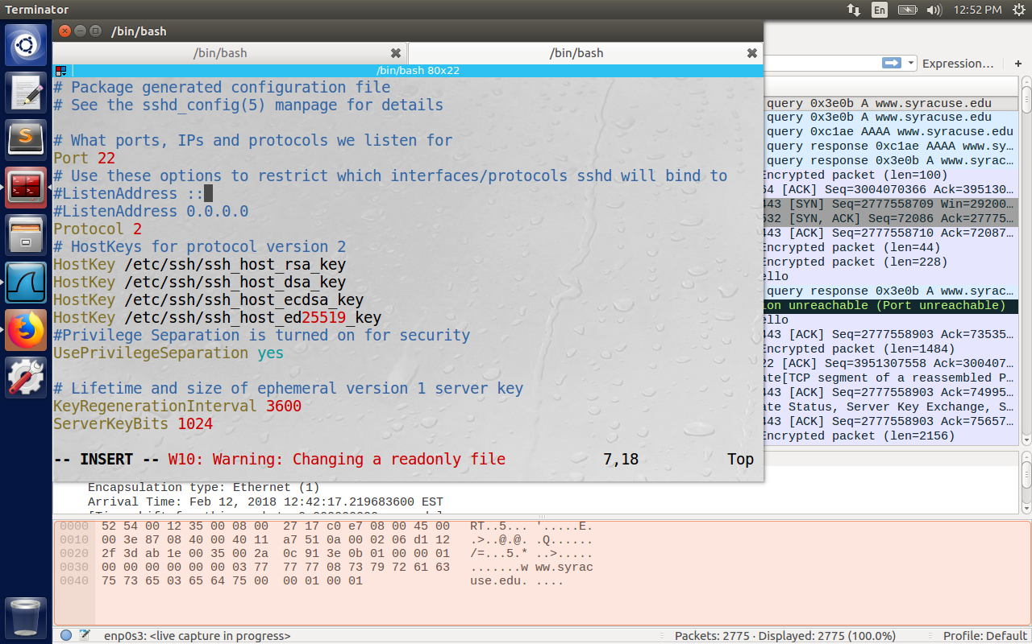

**Task 4: Web Proxy (Application Firewall)**

A widely used category of application firewalls is web proxy. which is used to control what their protected browsers can access. This is a typical egress filtering, and it is widely used by companies and schools to block their employees or students from accessing distracting or inappropriate web sites. Used the command “sudo apt-get install squid”. To restart the service every time, we make some config changes, use “sudo systemctl restart squid.service”.

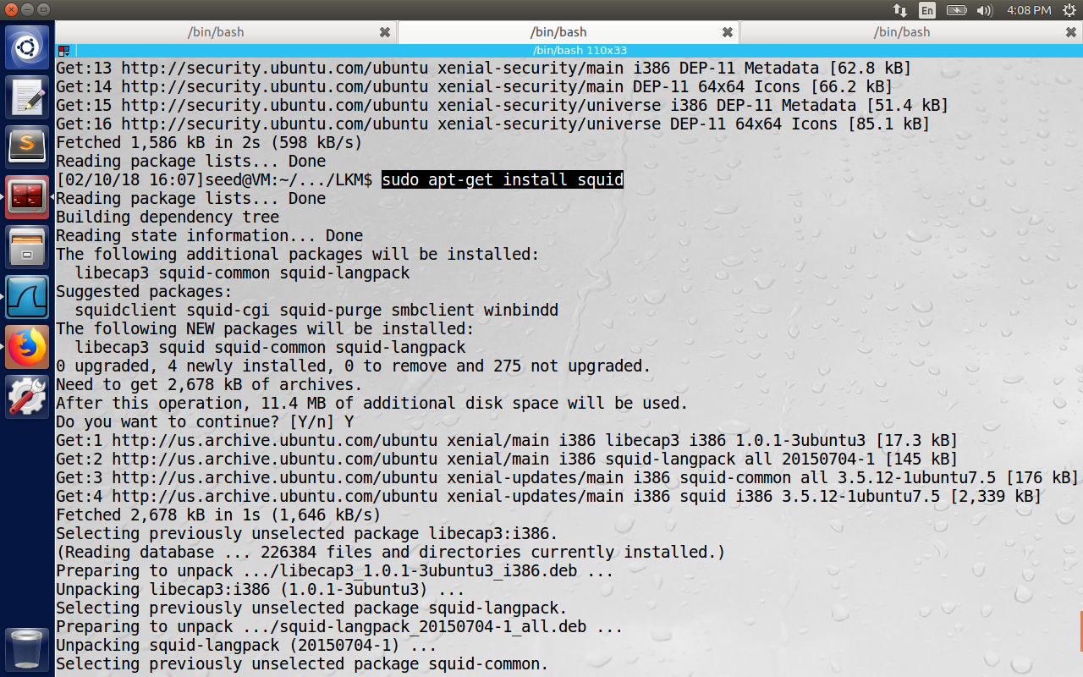

Task 4.a: Setup.

We need to restrict the browsing behavior of Machine A, we run the web proxy on Machine B.

Configured Machine A to use B as the proxy under Manual Proxy Settings of Http Proxy.  
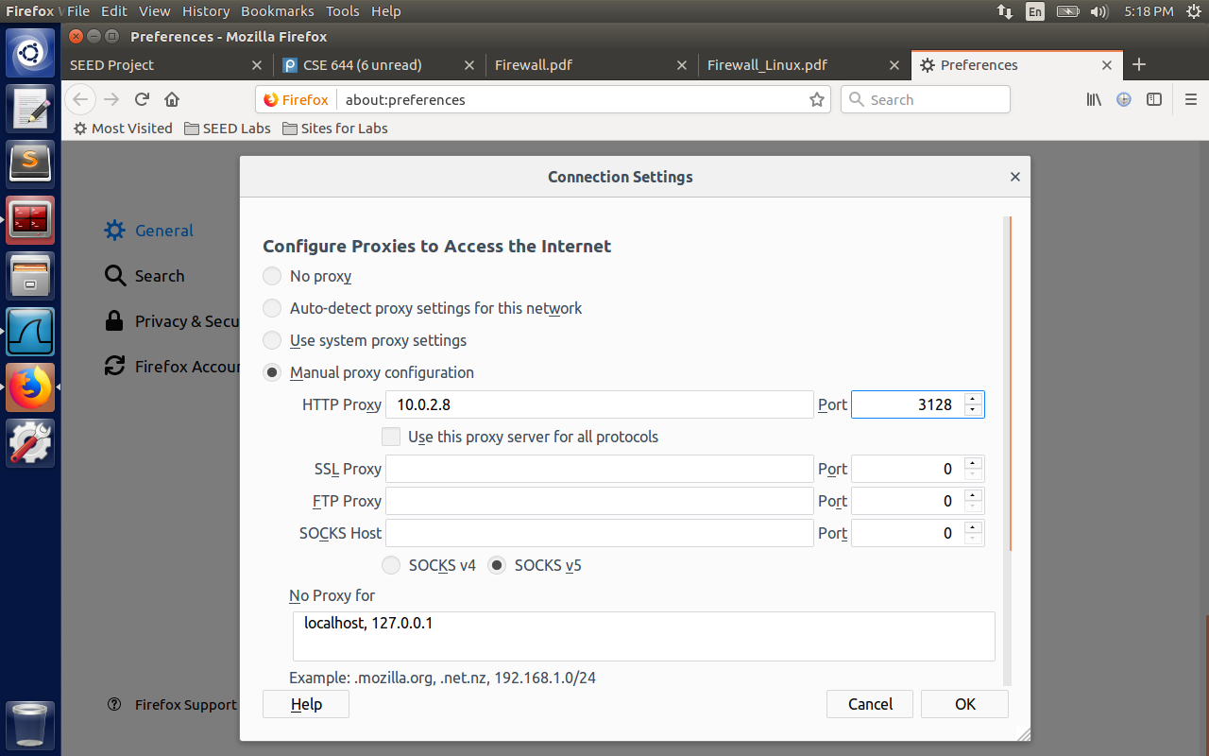

1.When the Machine A tries to open syr.edu, access is denied, because by default squid denies all the access.   
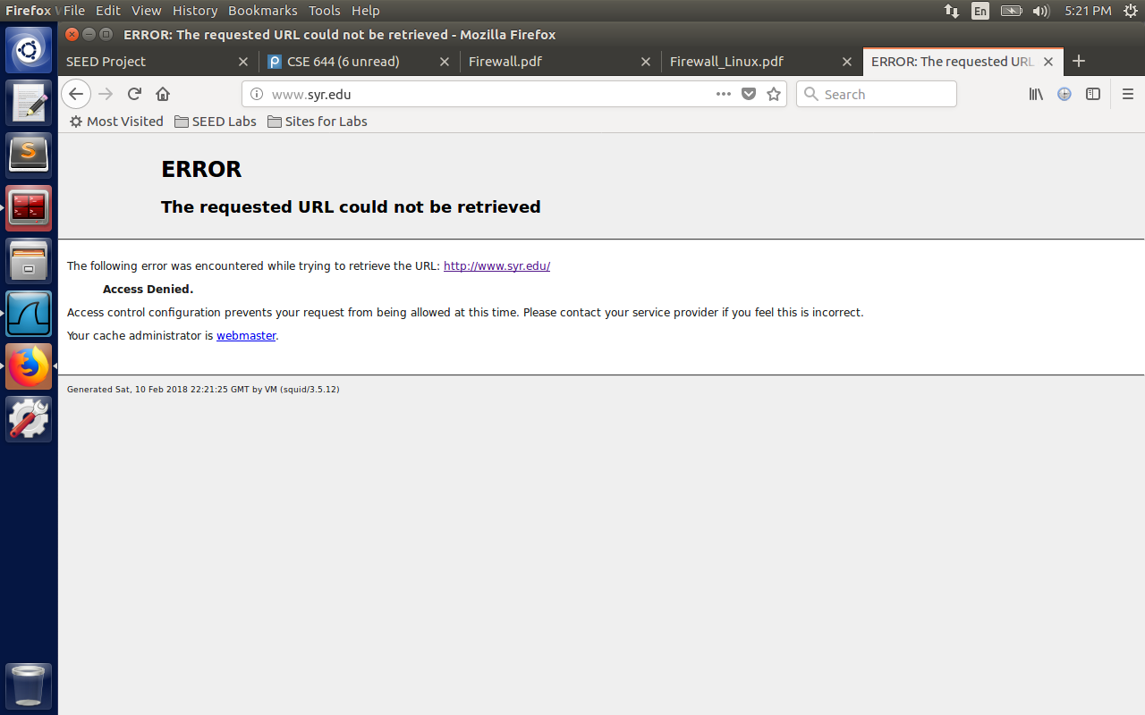

2. Opened the file /etc/squid/squid.conf If there are no access lines present, the default is to deny the request.

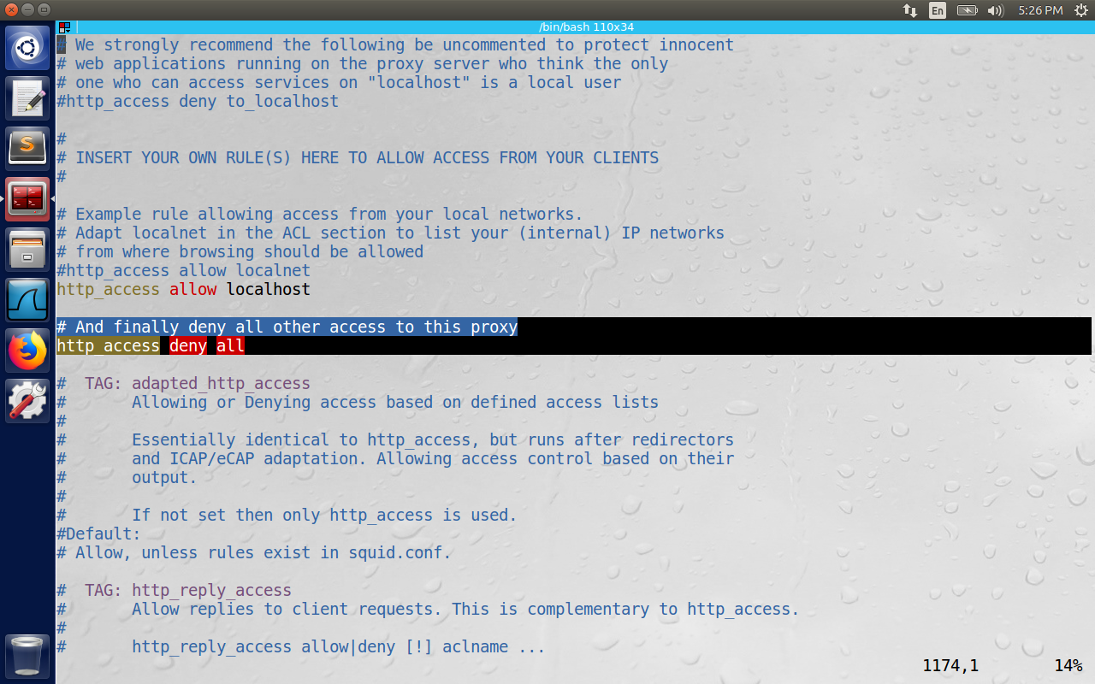

3. Make changes to the configuration file, so all the web sites are allowed

Now changed the config file with the rule “http_access allow all”. The syr.edu is now visited from VMA and is evident on the Wireshark.

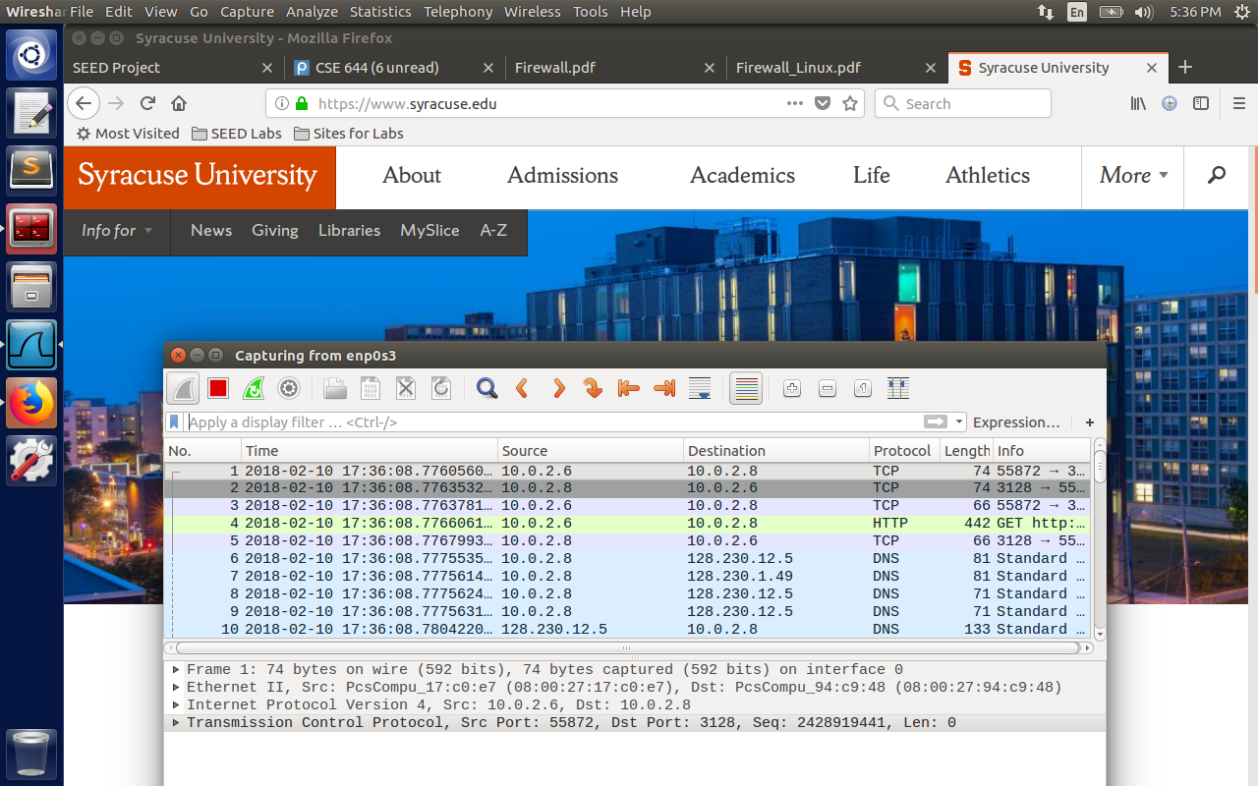

4. Make changes to the configuration file, so only the access to google.com is allowed

We observe in the below screenshot that http request is forbidden from VM2 (highlighted text)

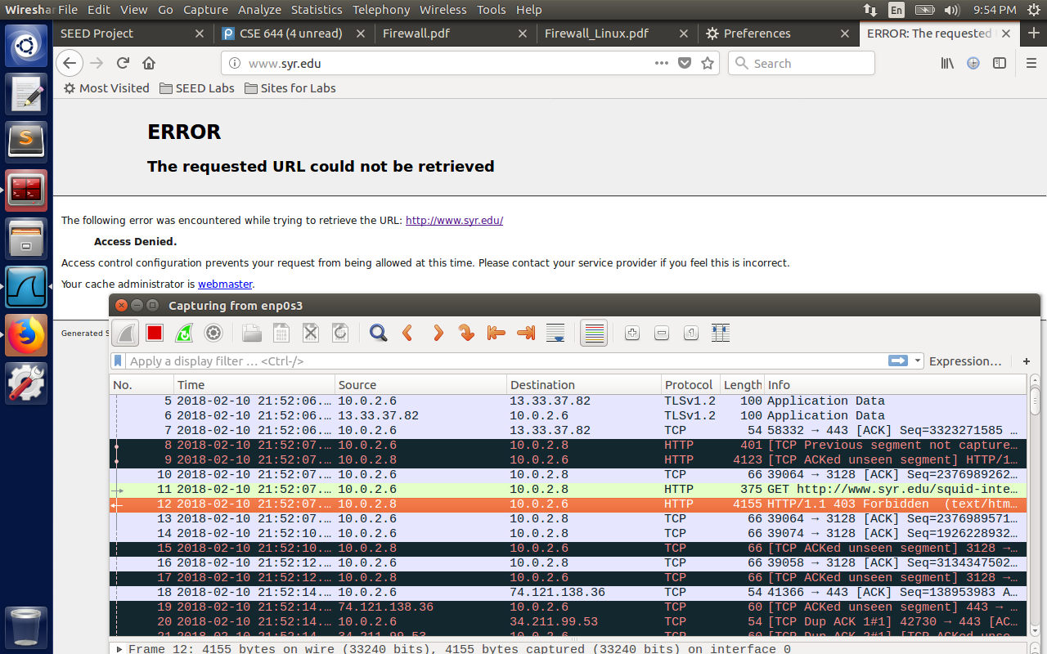

The following is the config changes made to allow only google.com and block other sites.

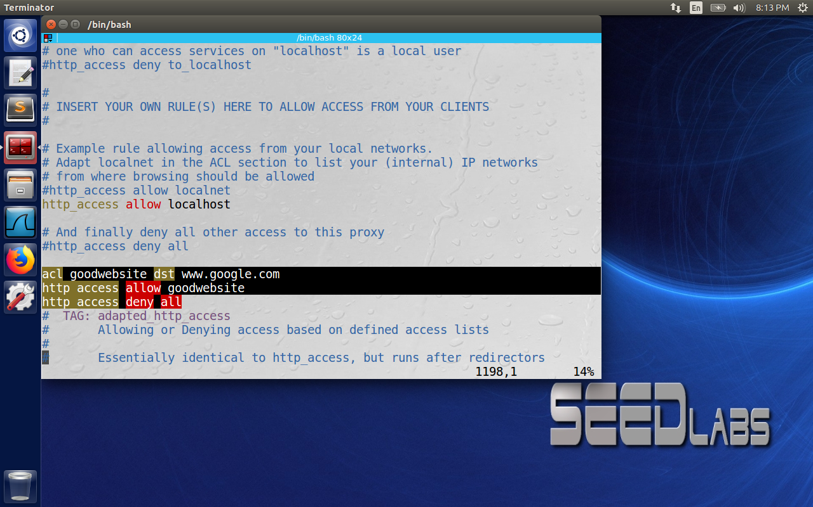

**Task 4.b: Using Web Proxy to evade Firewall**

Here instead of using google or facebook which can have multiple IP address, we will use syr.edu which is mostly have static IP address. So the ufw initially installs the firewall rule to block the destination IP of syr.edu, and we have to use web proxy to bypass the rules.

First I have configured the firewall to block the destination IP address of syr.edu as below.

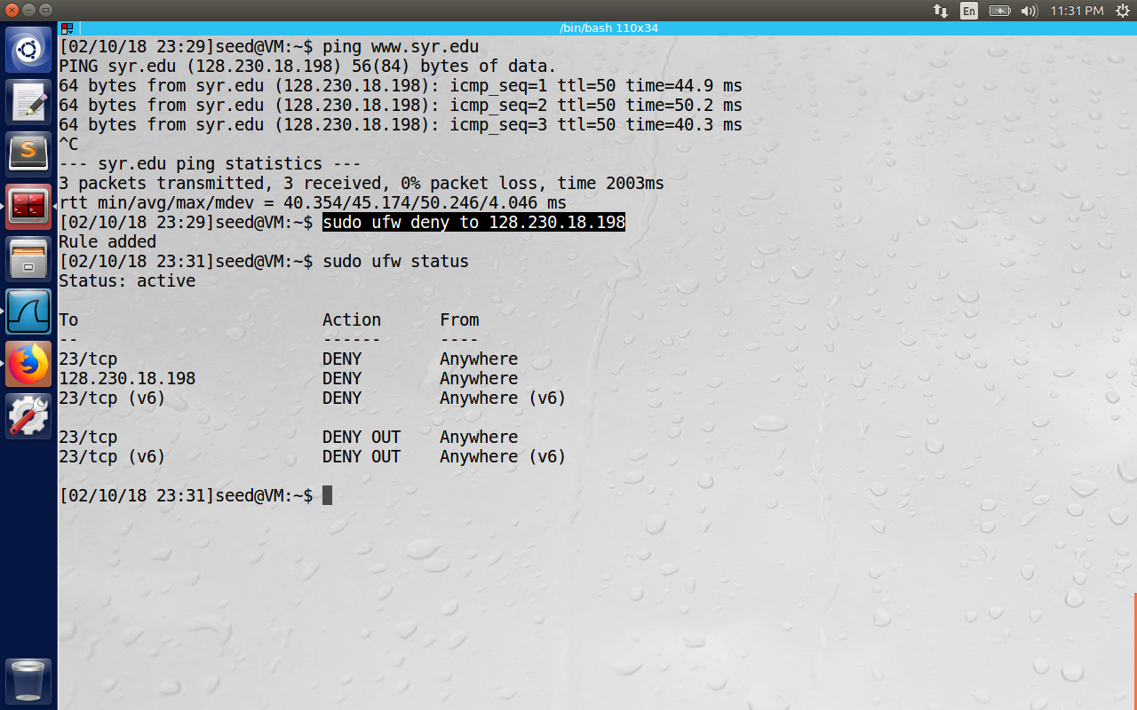

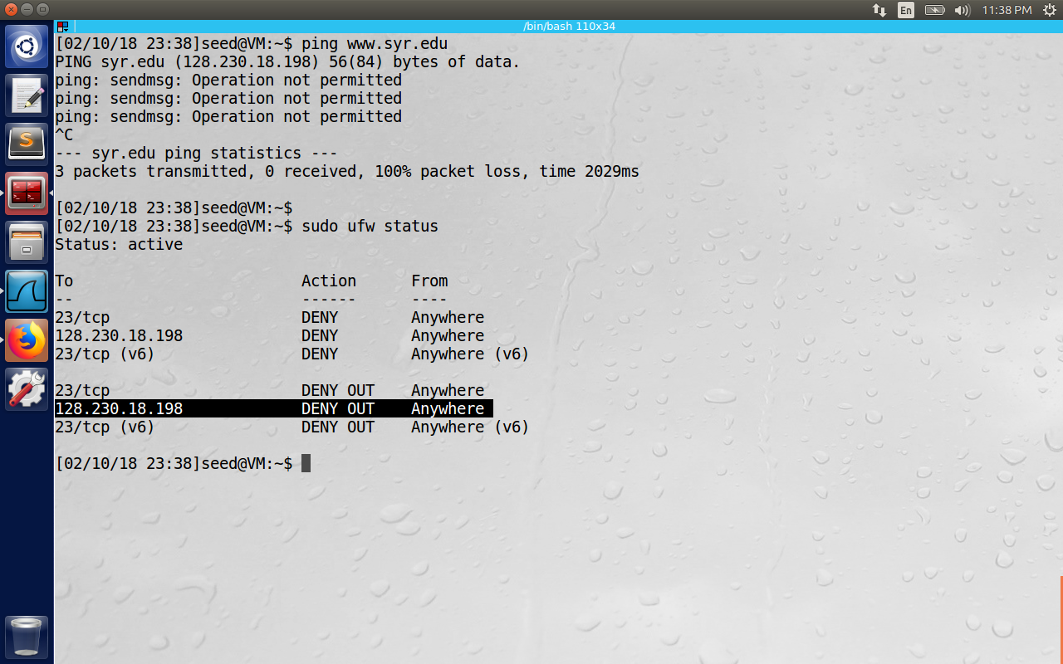

Now disable the manual proxy and we observe that we cannot reach syr.edu, because of the firewall rule installed. And we enable back manual proxy so that syr.edu is reachable with the help of web proxy on VM B.

We observe VM B making HTTP requests to syr.edu and sending the response to VM A even

After the firewall blocks the IP. (Here the response is 301 is because syr.edu is moved to Syracuse.edu)  
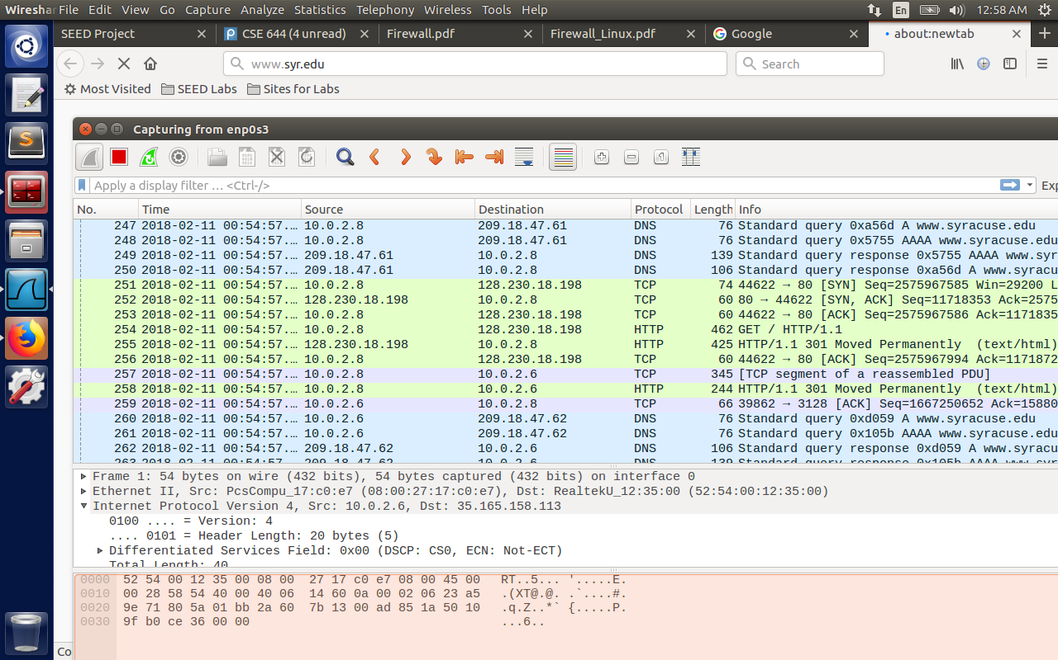

Question 5: If ufw blocks the TCP port 3128, can you still use web proxy to evade the firewall?

We can the proxy listening on VM B and we can still make requests and evade the firewall.

For this we need to change the listening ports on /etc/squid/squid.config file with other ports.

**Task 4.c: URL Rewriting/Redirection**

When squid receives an URL from browsers, it will invoke myprog.pl, which can get the URL information from the standard input (the pipe mechanism is used). The rewriting program can do whatever it wants to the URL, and eventually print out a new URL or an empty line to the standard output, which is then piped back to squid. Squid uses this output as the new URL, if the line is not empty.

1. Please describe what the above program does (e.g. what URLs got rewritten and what your observations are).

#!/usr/bin/perl -w

use strict;

use warnings;

# Forces a flush after every write or print on the STDOUT

select STDOUT; $| = 1;

# Get the input line by line from the standard input.

# Each line contains an URL and some other information.

while (<>) {

my @parts = split;

my $url = $parts[0];

# If you copy and paste this code from this PDF file,

# the ˜ (tilde) character may not be copied correctly.

# Remove it, and then type the character manually.

if ($url =˜ /www\.cis\.syr\.edu/) {

# URL Rewriting print "http://www.yahoo.com\n";

} else {

# No Rewriting. print "\n";

}

}

Here the cis.syr.edu website will be redirected to [www.yahoo.com](http://www.yahoo.com). (But ideally squid works only for http URL hence the redirection may not be successful)

2.Please modify the above program, so it replaces all the Facebook pages with a page that shows a big red stop sign.

Here as mentioned in the piazza form, instead of Facebook which is a https request, used the URL as <http://www.bbc.com> and the redirection url as <http://www.cis.syr.edu/~wedu/seed/img/setup_img.png> . The program is as below.

#!/usr/bin/perl -w

use strict;

use warnings;

# Forces a flush after every write or print on the STDOUT

select STDOUT; $| = 1;

# Get the input line by line from the standard input.

# Each line contains an URL and some other information.

while (<>)

{

my @parts = split;

my $url = $parts[0];

# If you copy and paste this code from this PDF file,

# the ~(tilde) character may not be copied correctly.

# Remove it, and then type the character manually.

#if ($url =~ m#^http://foo\.example\.com(/.*)?#i) {

#}

if ($url =~ m#^http://www\.bbc\.com(/.*)?#i) {

# URL Rewriting

print "http://www.cis.syr.edu/~wedu/seed/img/setup_img.png\n";

}

else {

# No Rewriting.

print "\n";

}

}

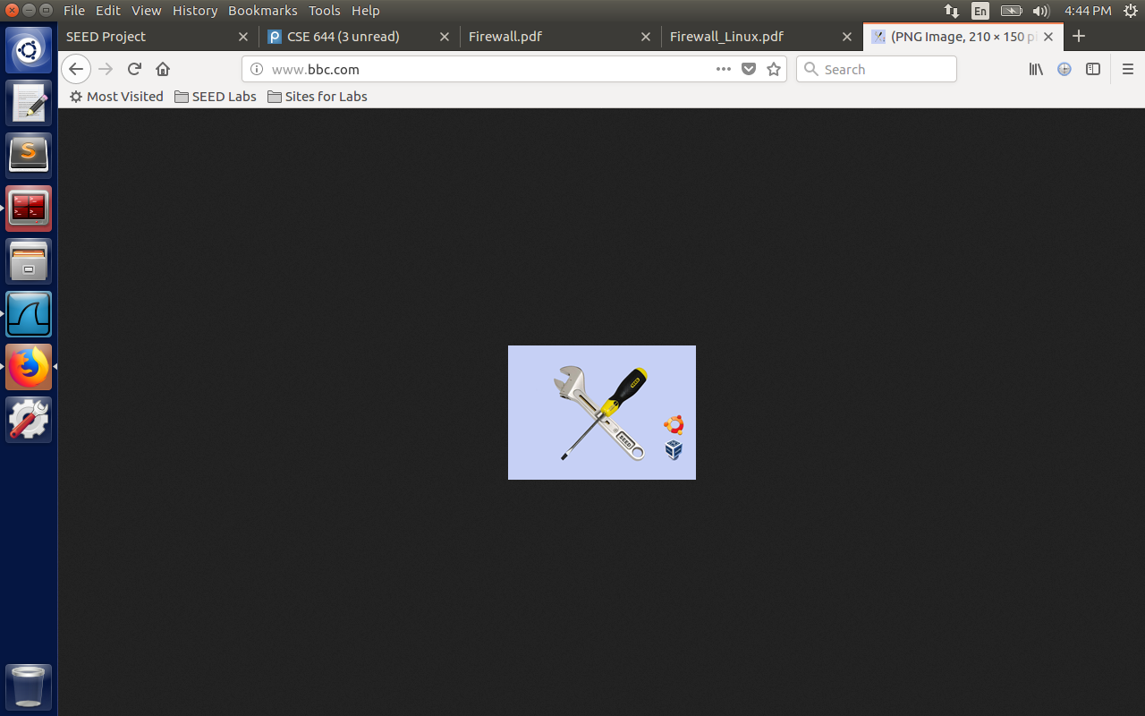

3. Please modify the above program, so it replaces all the images (e.g. .jpg or .gif images) inside any page with a picture of your choice. When an HTML web page contains images, the browser will identify those image URLs, and send out an URL request for each image. You should be able to see the URLs in your URL rewriting program. You just need to decide whether a URL is trying to fetch an image file of a particular type; if it is, you can replace the URL with another one (of your choice).

Here all the URL are parsed based on extensions of jpeg, jpg, bmp etc. and replaced will the images as in the image shown next.

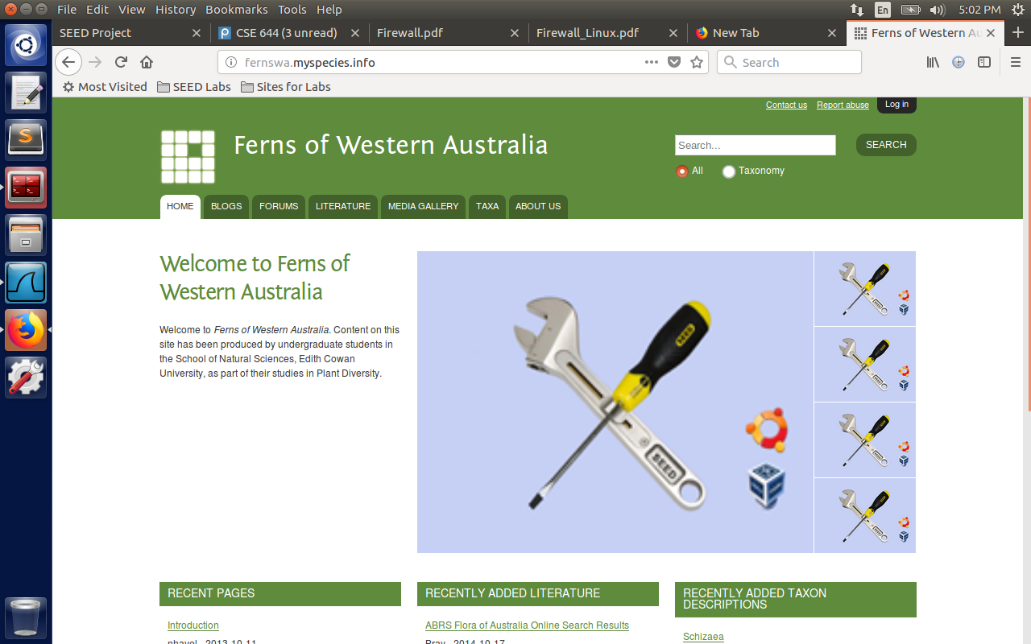

The URL visited is http based (<http://www.fernswa.myspecies.info>).

#!/usr/bin/perl -w

use strict;

use warnings;

# Forces a flush after every write or print on the STDOUT

select STDOUT; $| = 1;

# Get the input line by line from the standard input.

# Each line contains an URL and some other information.

while (<>)

{

my @parts = split;

my $url = $parts[0];

# If you copy and paste this code from this PDF file,

# the ~(tilde) character may not be copied correctly.

# Remove it, and then type the character manually.

#if ($url =~ m#^http://foo\.example\.com(/.*)?#i) {

#}

if ($url =~ /\.(jpg|bmp|gif|jpeg)/) {

# URL Rewriting

print "http://www.cis.syr.edu/~wedu/seed/img/setup_img.png\n";

}

else {

# No Rewriting.

print "\n";

}

}

**Question 6:** We can use the SSH and HTTP protocols as tunnels to evade the egress filtering. Can we use the ICMP protocol as a tunnel to evade the egress filtering? Please briefly describe how.

The ICMP packet contains the following fields: Packet Type (Echo request/response), Code, Header Checksum, Data (Variable Length). Here IP packet can be encapsulated inside the data field just same as like in SSH and HTTP. So we can use icmp protocol to build tunnels to evade the egress filtering. On the other end, the server decapsulates the packets and forwards the payload which is IP packet to the destination. The echo reply path again follows the reverse path of echo request to reach the client.